Project Design Phase-II
Data Flow Diagram & User Stories

Date | 28-06-2026
Team ID
Project Name | Nutrition Assistant
Maximum Marks | 4 Marks

Data Flow Diagrams:
Context Diagram (Level 0 DFD) Level-1 Data Flow Diagram
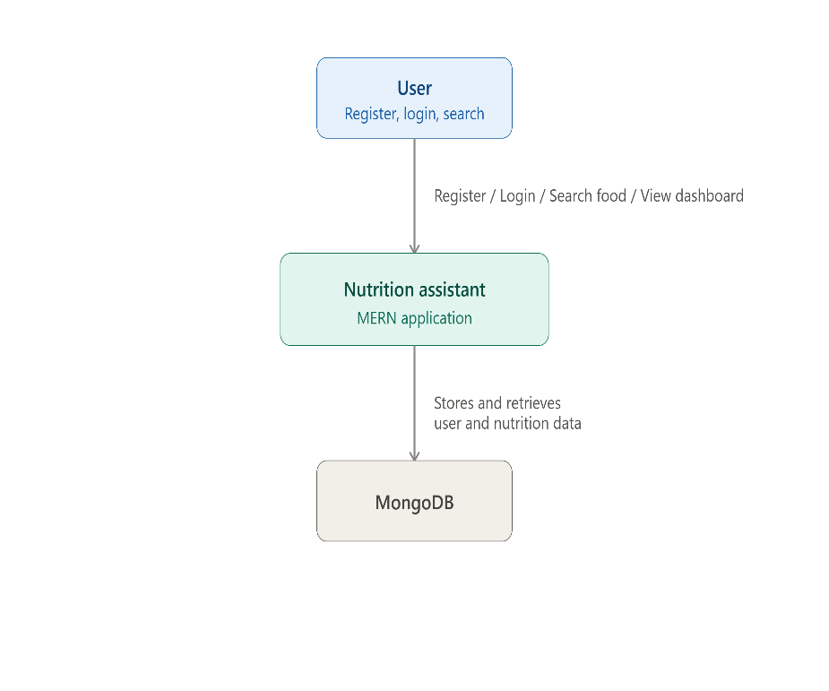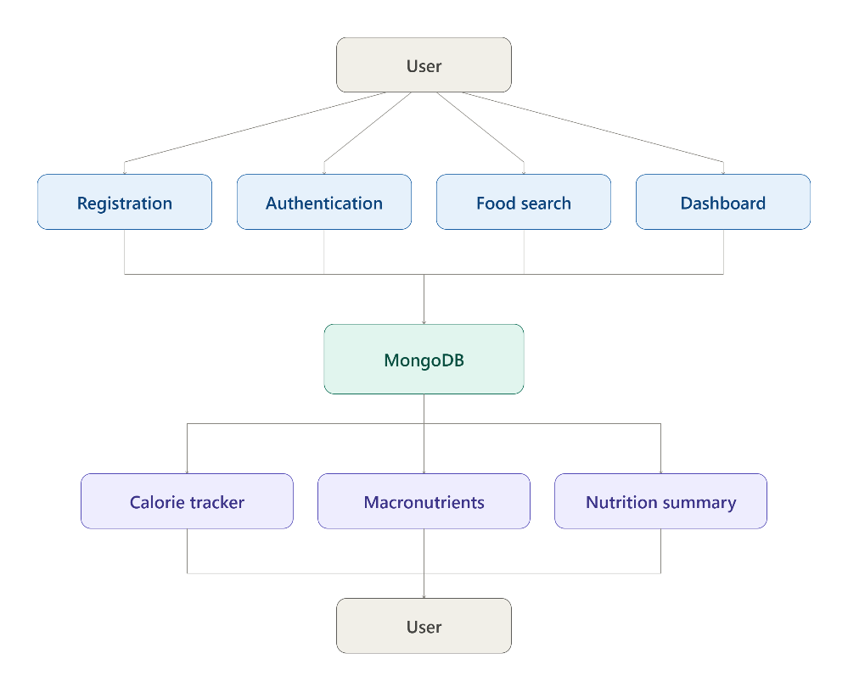

User Stories
User Type | Functional Requirement (Epic) | User Story Number | User Story / Task | Acceptance Criteria | Priority | Release
Customer (Web User) | Registration | USN-1 | As a user, I can register by providing my name, email, and password. | Account is created successfully and user can log in. | High | Sprint-1
 | Login | USN-2 | As a user, I can log in using my registered email and password. | User is redirected to the dashboard after successful login. | High | Sprint-1
 | Dashboard | USN-3 | As a user, I can access my nutrition dashboard after login. | Dashboard displays nutrition summary and calorie statistics. | High | Sprint-1
 | Food Search | USN-4 | As a user, I can search for food items from the nutrition database. | Matching food items are displayed successfully. | High | Sprint-1
 | Nutrition Details | USN-5 | As a user, I can view nutritional information including calories, protein, carbohydrates, and fats for a selected food item. | Nutritional values are displayed correctly. | High | Sprint-1
 | Calorie Tracking | USN-6 | As a user, I can track my daily calorie intake. | Daily calorie consumption is updated automatically. | High | Sprint-2
 | Macronutrient Tracking | USN-7 | As a user, I can monitor protein, carbohydrates, and fat intake throughout the day. | Macronutrient totals are calculated correctly. | High | Sprint-2
 | Nutrition Dashboard | USN-8 | As a user, I can view my daily nutrition summary and macronutrient distribution. | Dashboard charts and summaries are displayed correctly. | High | Sprint-2
Customer (Web User) | Responsive Interface | USN-9 | As a user, I can use the application smoothly on desktop, tablet, and mobile devices. | Application is fully responsive across different screen sizes. | Medium | Sprint-2
 | Logout | USN-10 | As a user, I can securely log out of the application. | User session ends and login page is displayed. | High | Sprint-1

Administrator
User Type | Functional Requirement | User Story Number | User Story / Task | Acceptance Criteria | Priority | Release
Administrator | User Management | USN-11 | As an administrator, I can view all registered users. | Registered users are displayed successfully. | High | Sprint-2
 | Food Database Management | USN-12 | As an administrator, I can add new food items to the nutrition database. | Food item is stored successfully in MongoDB. | High | Sprint-2
 | Food Database Management | USN-13 | As an administrator, I can update nutritional information for existing food items. | Updated nutrition information is reflected immediately. | High | Sprint-2
 | Food Database Management | USN-14 | As an administrator, I can delete outdated or incorrect food records. | Food item is removed successfully. | Medium | Sprint-3
 | Dashboard Monitoring | USN-15 | As an administrator, I can monitor application usage and user activity. | Application statistics are displayed correctly. | Medium | Sprint-3

